4th Annual Mt. Grant Challenge Draws Large Crowd
The 4th Annual 911 Memorial Mt. Grant Challenge held on Saturday, September 13th, near Hawthorne, Nevada. An official Nevada 150 event, finisher’s each received a specially minted challenge coin/geodetic marker replica with the Sesquicentennial logo on the back. The Challenge was to hike to the top of the highest point in Mineral County, Mt. Grant which towers over the community at 11,239 feet. Most of the 94 participants began before sunrise near Walker Lake at an elevation of a little more than 4200 feet. Although the air was brisk in the morning, high temperatures made this year’s Challenge, well, a bit more challenging to those who scaled the 7000 feet incline hike.
The event included more than 20 local youth who were invited to participate and given free access to this year’s event because of generous sponsorship donations. With all the volunteers, emergency personnel and participants more than 120 people enjoyed the day on the mountain trail.
The 911 Memorial Challenge Committee has been meeting for months to organize the event which clearly supports the community of Hawthorne’s theme of “America’s Patriotic Home.” The Challenge is designed to be both mentally and physically grueling and proceeds from the event helps support the maintenance of the community’s Veterans Memorial Park and the flying of one of the largest American flags in the state of Nevada. Offering continuous support and resources since the Challenge’s inception, both SOC Nevada LLC and the Hawthorne Army Depot have been instrumental in sustaining this event. When the support of the firefighters, EMT’s and law enforcement is added in, the event is quite a testimony to the memory of 911.
This year the youngest hikers were 10-years old, completing the most grueling portion of the climb and receiving their finisher’s coins. The eldest competitor was a 74-year old man from Illinois, who was among the 43 participant from out of the area. Finishers of this year’s event included Lt. Col. Gregory Gibbons, commander of the Hawthorne Army Depot, the current Mineral County Sheriff and deputies, Hawthorne Volunteer Fire Department Chief and SOC Nevada’s Fire Chief. The first to reach to summit was Michael Christenson of Fernley, Nevada, finishing in 4 hours 49 minutes.
Demonstrating the viability of this event as a tourism draw, 43 participants were from out of the area. Funds from the Mineral County Fair and Recreation Board have helped promote this event for the past two years and it is anticipated that a grant from the Nevada Commission on Tourism will be applied for next year. Participants from out-of-town were:
Luca Baradel, San Francisco, California
Betty Bishop, Reno, Nevada
Ephrat Bitton , San Francisco, California
Roy and Marlene Begay, Schurz, Nevada
Michael Berry, Crater Lake, Oregon
Patrick Botsford, Pleasant Hill, Washington
Connie Brant, Reno, Nevada
Kerry Breen, Tracy, California
Kyle Breen, Vallejo, California
Jay Bruins, Los Altos, California
Lisa Buckley, Corona del Mar, California
Josh Carlson, Coal Valley, Illinois
Michael Christiansen, Fernley, Nevada
Jason Dean, Sparks, Nevada
Jay Dolan, San Diego, California
Heather Edwall, Mammoth Lakes, California
Dick Ellsworth, Quincy, Illinois
Amanda Etheridge, Elko, Nevada
Mihai Giurgiulescu, Valley Village, California
Stephanie Goodwin, Fallon, Nevada
Robert Greco, Sparks, Nevada
Tana Gurule
Gwen Hosey, Wellington, Nevada
Brian Kharrl, Fallon, Nevada
Andrew Kirmse, Redwood City, California
Kyle Leslie, Carson City, Nevada
John Lockwood, Schurz, Nevada
Sunny Martin, Sparks, Nevada
Deanna McAninch, Reno, Nevada
Sara Mikulich, Fallon, Nevada
Ramie Millsap, Reno, Nevada
Juanita Navarro, San Clemente, California
Gary Novotny, Reno, Nevada
Gerry Pennington, Spring Creek, Nevada
Theodore Pfister, South Lake Tahoe, California
Chris Prince, San Francisco, California
Keith Randall, Los Altos Hills, California
Andres Schriner, Richmond City, Califrona
Arvin and Janice Shepherd, Grand Junction, Colorado
Vicki Varain, Schurz, Nevada
Jeff Webb, Hawaii

Of course, the event wouldn’t be a success without our local participants:
Tammy Adams
Oya Bryant
Sherry Cardenas
Shannon Erickson
Lt. Col. Gregory Gibbons
Matthew Goodrich
Randy Gurule
Sheriff Stewart Handt
Amanda Kunzi
Rose Laing
Cheri Lockwood
Rob Mathias
Nellie Morgan
LaReita Parker
Amanda Peterson
Phyllis Rebottaro
District Attorney Sean Rowe
Tiffany Shields
Jim Stallings
Chris Summerbell
Kathy Trujillo
Tina Trujillo
Dave Womack

This year there were two participants from the Hawthorne Intermediate School ( 10-years old) who completed a portion of the climb with the assistance of Karen Womack and who received their finisher’s coins:
Sofia Castillo-Trujillo
Braeden Womack

Sponsored participants from Mineral County High School who participated in the complete Challenge were:
Alfonso Castillo-Trujillo
Dory E. Dudley
Taylor Fund
Juan Hernandez
Ryan Holley
Miles King
Kyler Musselmann
Diego Pittman
Tristan Reynolds
Shyla Regusi
Paul Rodriques
Peter Rowe
Julian Rudd
Trudi Sandvick
Michael Smith
Chance Sterns
Rebecca Wadlow
Michael Wadlow
Brandon West

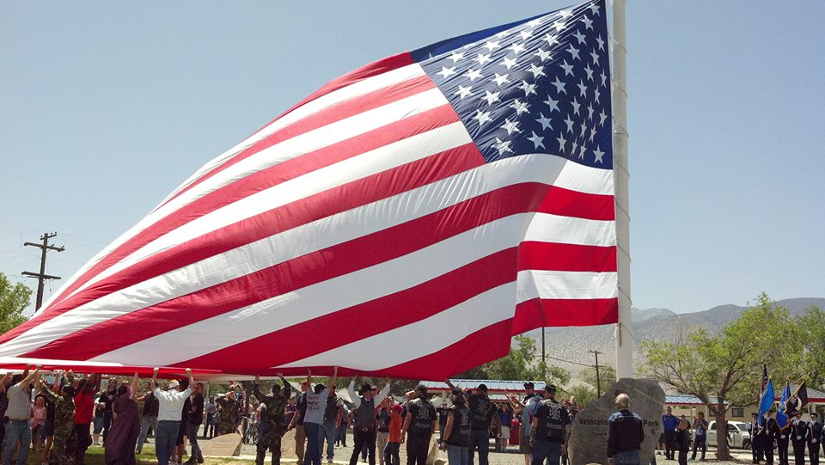
Hawthorne’s big flag being raised at Veteran’s Memorial Park during the annual Armed Forces Day Celebration. Photo by Beverly Orozco, Hawthorne, Nevada
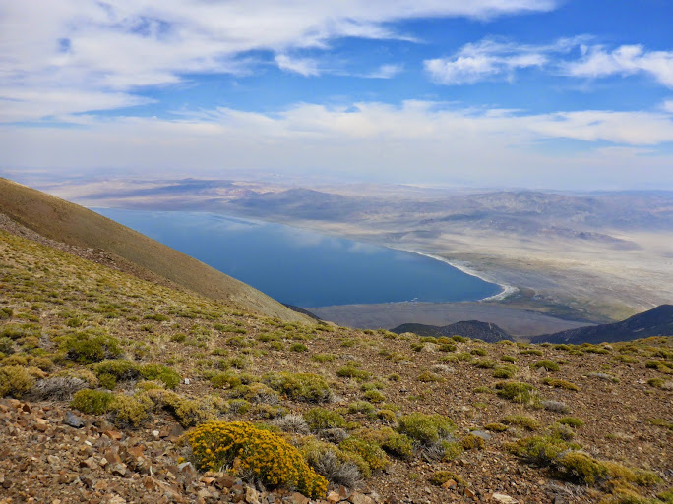
In addition to a specially designed Nevada Sesquicentennial finisher’s coin and commemorative t-shirt, those completing the 911 Memorial Mt. Grant Challenge are treated to an exceptional view of Walker Lake, the Army Ammunition Depot and the community of Hawthorne. On a clear day, one can see nearby mountain ranges that are 120 miles away.
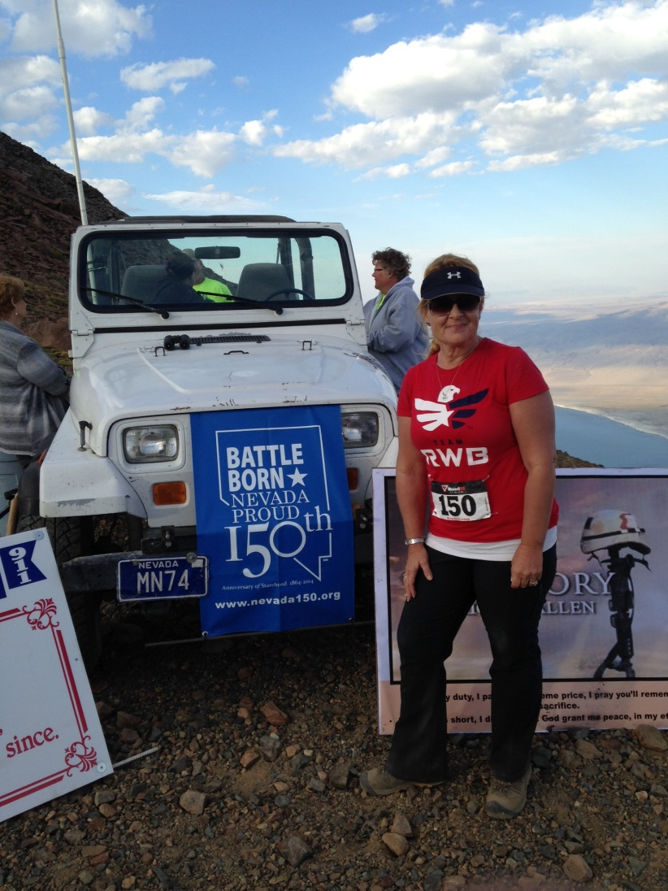
One of the last to finish this year’s 911 Memorial Mt. Grant Challenge was No. 150, Kathy Trujillo a member of Team YOLO (You Only Live Once) consisting of Hawthorne Volunteer Fire Department Chief, Dave Womack, Oya Bryant, and SOC Fire Chief Robert Mathias. The trek took them well over 10 hours.

