5th Annual Mt. Grant Challenge Draws Large Crowd
The 5th Annual 911 Memorial Mt. Grant Challenge held on Saturday, September 12th, near Hawthorne, Nevada. The Challenge was to hike to the top of the highest point in Mineral County, Mt. Grant which towers over the community at 11,239 feet. Most of the 97 participants began before sunrise near Walker Lake at an elevation of a little more than 4200 feet. Although the air was brisk in the morning, high temperatures made this year’s Challenge, well, a bit more challenging to those who scaled the 7000 feet incline hike.
More than a dozen local youth participated in the event this year having raised pledges from friends and family to support the event which earmarks all proceeds to the Veteran’s Memorial Park and the flying of the big flag. With all the volunteers, emergency personnel and participants more than 150 people enjoyed the day on the mountain trail.
The 911 Memorial Challenge Committee has been meeting for months to organize the event which clearly supports the community of Hawthorne’s theme of “America’s Patriotic Home.” The Challenge is designed to be both mentally and physically grueling. A trend with many endurance events is to offer a “half,” and this year a 9.11 mile hike was offered with many individuals and families participating in this scaled down version of the Challenge. Both SOC Nevada LLC and the Hawthorne Army Depot have been instrumental in sustaining this event. This year the committee was able to obtain a $10,000 Commission on Tourism Grant to support regional advertising and additional marketing materials.
As September 11th fell on a Friday, a 911 Processional Parade was held with participants and community members meeting at the park for a commemorative service, free spaghetti dinner (compliments of Barley’s) and packet pick up. This addition to the event was very well received.
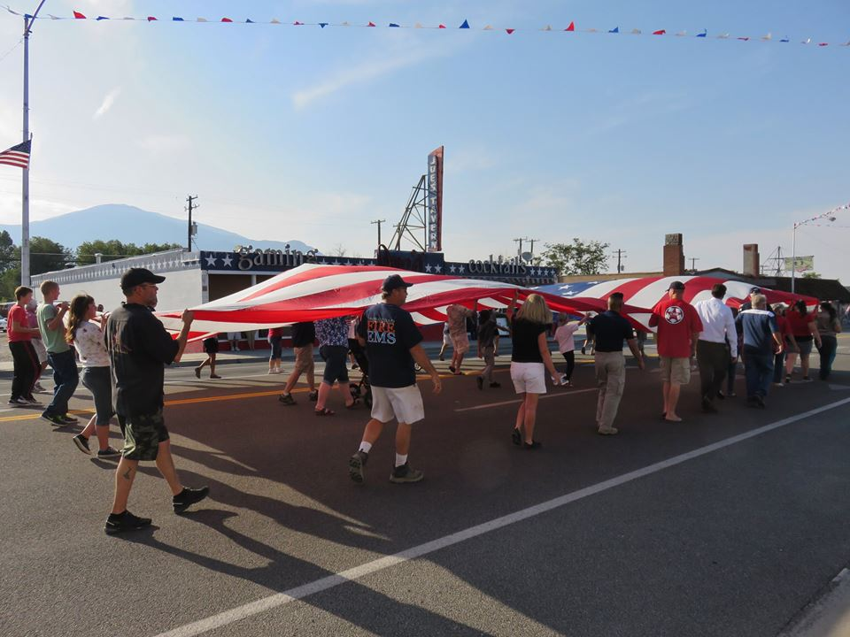
Demonstrating the viability of this event as a tourism draw, nearly half of the participants were from out of the area. Funds from the Mineral County Fair and Recreation Board have helped promote this event and a $10,000 Nevada Commission on Tourism Grant was awarded to support advertising.
Participants from:
Albany, California
Carson City, Nevada
Elko, Nevada
Fallon, Nevada
Gardnerville, Nevada
Hawthorne, Nevada
Las Vegas, Nevada
Larkspur, California
Los Gatos, California
Mammoth Lakes, California
Martinez, California
Mina, Nevada
Pleasant Hill, Washington
Redwood City, California
Reno, Nevada
San Jose, California
Schurz, Nevada
Seaside, California
Shingle Springs, California
Sparks, Nevada
Sylmar, California
Tonopah, Nevada

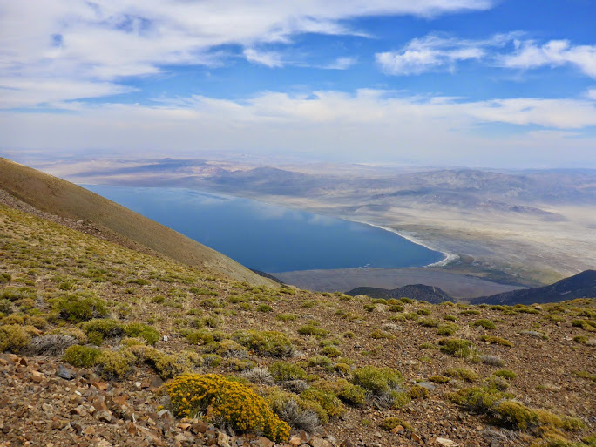
In addition to a specially designed finisher’s coin and commemorative t-shirt, those completing the 911 Memorial Mt. Grant Challenge are treated to an exceptional view of Walker Lake, the Army Ammunition Depot and the community of Hawthorne. On a clear day, one can see nearby mountain ranges that are 120 miles away.

